## 特殊矩阵

>> A=zeros(2,3)

A =

0 0 0

0 0 0

>> zeros(size(reshape(A,3,2)))

ans =

0 0

0 0

0 0



>> A=fix(10+(99-10+1)*rand(5))

A =

78 73 84 49 54

76 12 72 44 50

45 34 38 78 68

68 14 95 81 73

25 18 13 26 77

>> B=0.6+sqrt(0.1)*randn(5)

B =

0.3269 1.0847 0.2556 0.6272 0.4053

0.6245 0.3566 0.6103 0.1283 0.8366

0.2161 0.7174 0.7747 0.3653 0.5392

0.2479 0.5287 0.9480 0.2643 0.8810

0.5978 0.9533 1.0883 1.3433 0.3581

>> C=eye(5)

C =

1 0 0 0 0

0 1 0 0 0

0 0 1 0 0

0 0 0 1 0

0 0 0 0 1

>> (A+B)*C==C*A+B*C

ans =

5×5 logical 数组

1 1 1 1 1

1 1 1 1 1

1 1 1 1 1

1 1 1 1 1

1 1 1 1 1

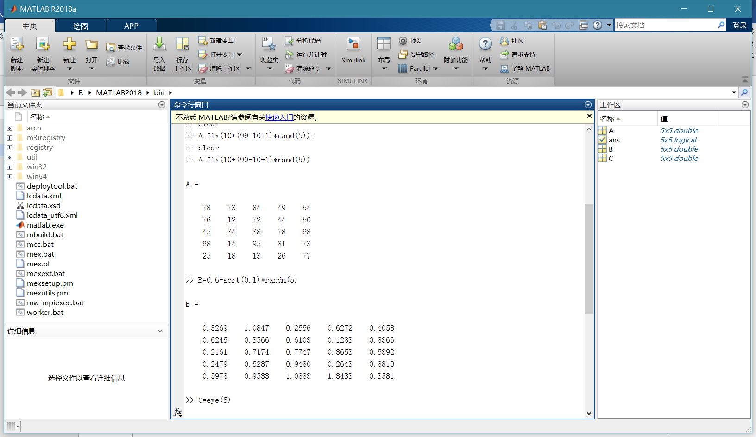

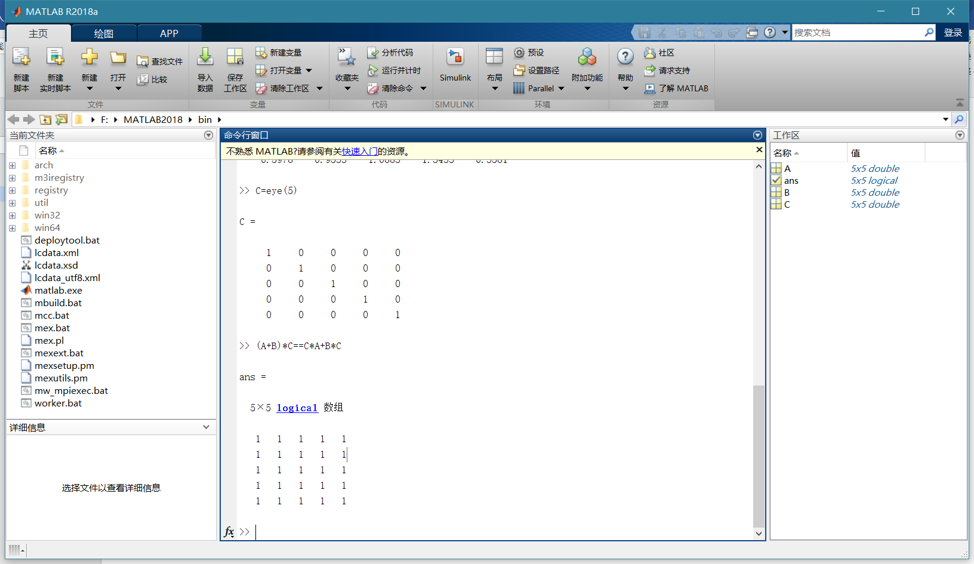

魔方矩阵

>> M=magic(3)

M =

8 1 6

3 5 7

4 9 2

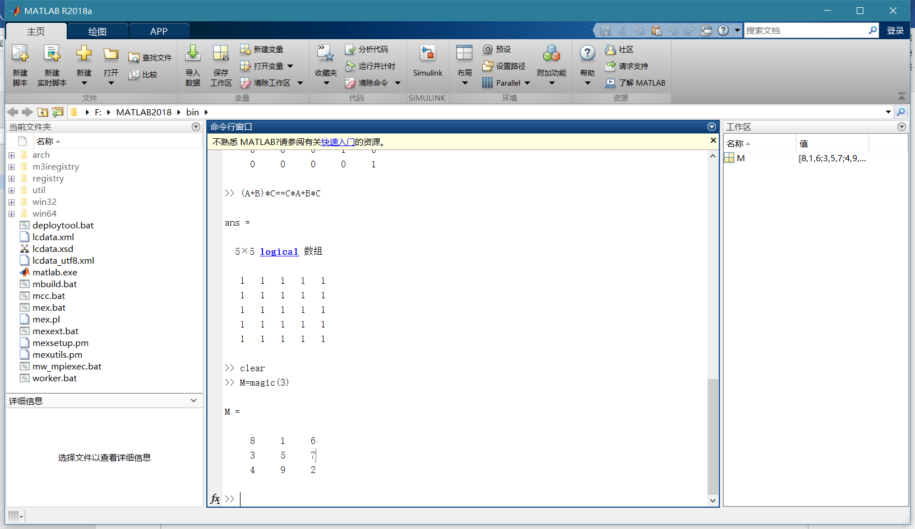

>> M=magic(8)

M =

64 2 3 61 60 6 7 57

9 55 54 12 13 51 50 16

17 47 46 20 21 43 42 24

40 26 27 37 36 30 31 33

32 34 35 29 28 38 39 25

41 23 22 44 45 19 18 48

49 15 14 52 53 11 10 56

8 58 59 5 4 62 63 1

>> sum(M(1,:))

ans =

260

>> sum(M(:,1))

ans =

260

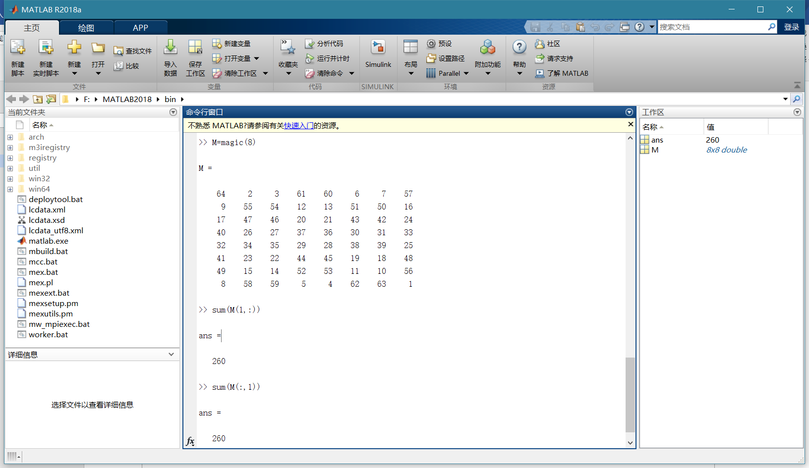

范德蒙矩阵：

>> A=vander(1:5)

A =

1 1 1 1 1

16 8 4 2 1

81 27 9 3 1

256 64 16 4 1

625 125 25 5 1

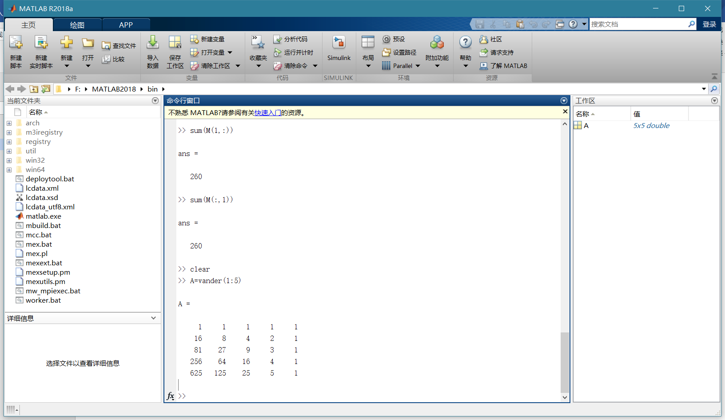

希尔伯特矩阵

>> format rat

>> H=hilb(4)

H =

1 1/2 1/3 1/4

1/2 1/3 1/4 1/5

1/3 1/4 1/5 1/6

1/4 1/5 1/6 1/7

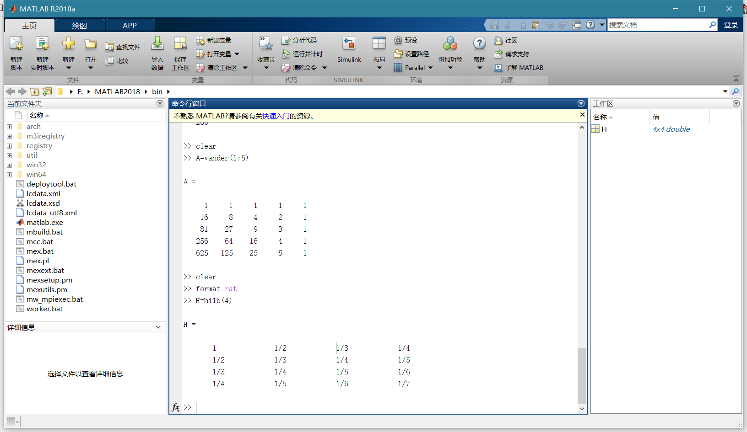

伴随矩阵

>> p=[1,-2,-5,6]

p =

1 -2 -5 6

>> A=compan(p)

A =

2 5 -6

1 0 0

0 1 0

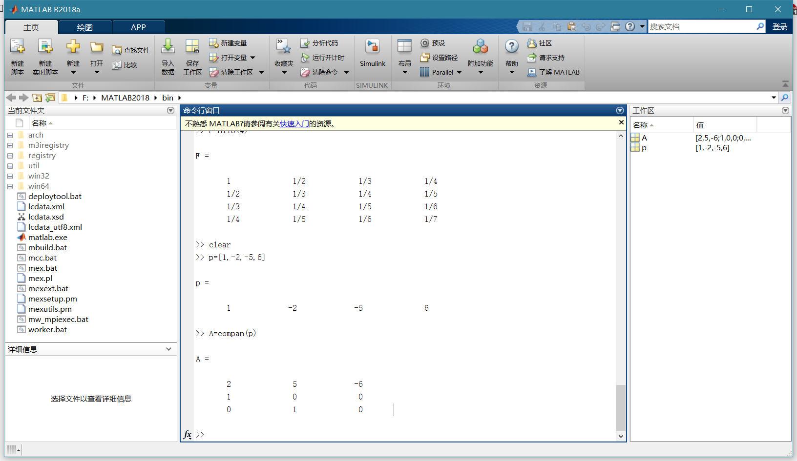

帕斯卡矩阵

>> format rat

>> P=pascal(5)

P =

1 1 1 1 1

1 2 3 4 5

1 3 6 10 15

1 4 10 20 35

1 5 15 35 70

>> inv(P)

ans =

5 -10 10 -5 1

-10 30 -35 19 -4

10 -35 46 -27 6

-5 19 -27 17 -4

1 -4 6 -4 1

